.

***Custom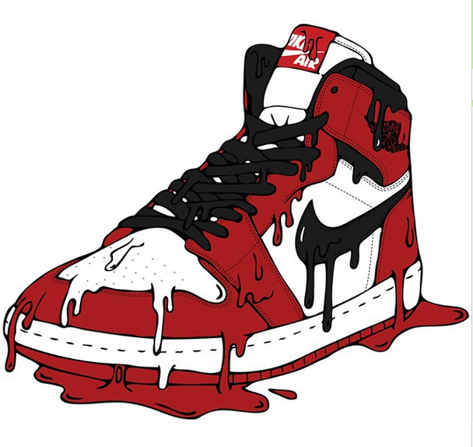Sneaks***

**Custom Sneaks:**

**Purpose:** Our website will specially be focused on the Sneakers Market. Our website will allow user to customize sneakers. Users can customize their own pair, or they can buy new pair of sneakers from our website and customize after that. Our website will also allow customer to restore their old shoes. This website will also provide a platform for our user to connect with designer, and learn about designing technique. Similarly, users can also hire designer to customize their shoes with some extra fee. Our page will include the sample of customized shoes, best shoes for customization, and designer suggestion.

**Audience:** Sneakers are worn by all age group, but they are very popular in younger generation. Hip-Hop, Basketball, and music have all tied with Sneakers industry. These three are the main reason for influencing younger generation to buy sneaker and customize it. Sneaker Market is valued at 60 billion dollars in 2019, according to the Tech Sci Research. And, Younger adults and kids were the main age group which spent lot of money to buy sneaker. Although, customization of sneaker are not very popular, but since last decade market value of sneaker customization has been growing rapidly. Therefore, our main audience or user will be young adults and kids.

**Competition:** The idea of customization is pretty new. [Nike by You](https://www.nike.com/nike-by-you), [KingSneakers](http://www.kingofsneakers.com/), and [Cutom Movement](https://www.thecustommovement.com/) are some of our competitors. These website does not provide lot of options for customization, and they are very hard to navigate. Our website will be easy to navigate, easy to use and will very colorful. Our website will be similar to Custom Movement website, but instead we will use vibrant color to catch the attention of younger users.

**These are some of the Mock-Up from Custom Movement Website:**

